**Experiment – 4**

**Familiarization of network IP and Subnetting and Super netting**

**Aim : Study of network IP and Sub netting and super netting**

**IP address classification**

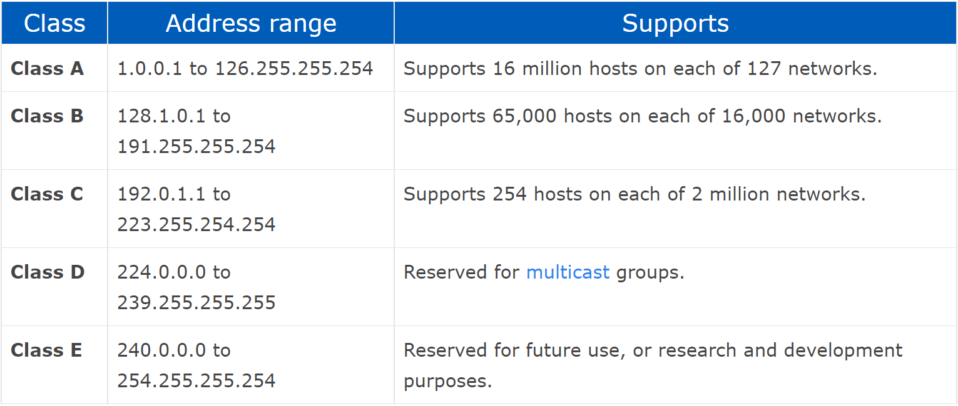

Subnet-Mask

When a bigger network is divided into smaller networks, in order to maintain security, then that is known as Subnetting. so, maintenance is easier for smaller networks.

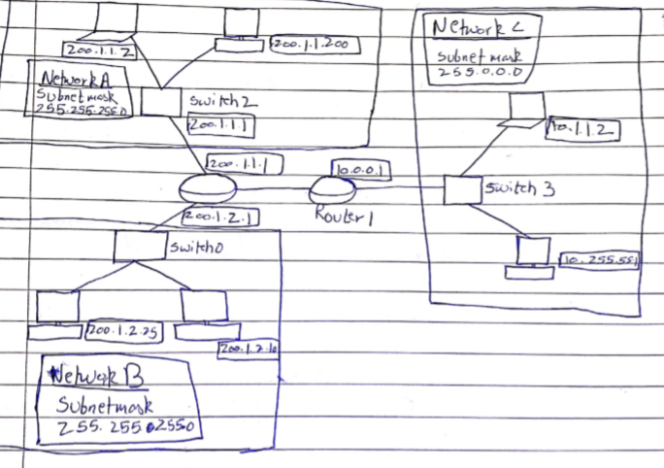

Super netting

Super netting is mainly used in Route Summarization, where routes to multiple networks with similar network prefixes are combined into a single routing entry, with the routing entry pointing to a Super network, encompassing all the networks.

